Outdoor Activities Consent and Medical Form
Andy’s Positive Programmes (APP) CIC collects the details on this form in order to provide for the safety and wellbeing of course participants.

Activity Details
Participant Name: |  | Age:  If under 18
Date of Activities:
Planned Activities:

Medical Details
Please declare any medical conditions, recent injuries, general health problems, medication you will have taken or be carrying and any dietary requirements. Our staff will discuss with you confidentially any impact these may have.
Medical Conditions: Include recent injuries/surgeries, etc.
Medication:
Allergies or intolerances: Food or otherwise
Special Dietary Requirements:
Vegetarian etc.

Emergency Contact
Please give a person we can contact if there is an emergency whilst you are undertaking the activity. For participants under 18 years of age this should be a parent/guardian.
Name: |  | Relation:
Phone Number(s):

Consent
By signing below I confirm I give my Consent for Activities. To be signed by parent/guardian for under 18s.
Signature: |  |  | Date:
Name of person signing:
If not the participant
⎦ Please mark this box if you consent to photographs being taken. These photos will be anonymised and may be used for the purposes of publicity

Andy’s Positive Programmes Declaration of Consent for Activities
To be read by activity participants and, for under 18s, a parent/guardian.
- I have read the ‘details of activities’ and understand the relevant description of activities.
- I agree that I will/my child will undertake the activities in accordance with the specific instruction instructor.
- I agree to wear/for my child to wear safety equipment issued and to follow all safety procedures.
- I understand that the activities consist of substantial and physically testing tasks.
- I accept that there is a risk of injury when undertaking such activities.
- In the unlikely event of an accident, or loss or damage to my personal effects, I acknowledge that Andy’s Positive Programmes will not be liable for any direct or indirect loss, damage or injury Arising from or in connection with the activities (except for death or personal injury caused by Andy’s Postitive Programmes negligence) and I waive all and any claims against Andy’s Positive Programmes and their instructors.

Confidentiality
For the safety and wellbeing of our activity participants it is important that the medical in provided to Andy’s Positive Programmes is complete and accurate. If, for reasons of confidentiality, you do not wish your details to be handled by a third party (group organiser, school office, etc) then please forward your completed form to Andrew Robinson directly prior to the event. Please ensure it is marked with your group name and booking dates.
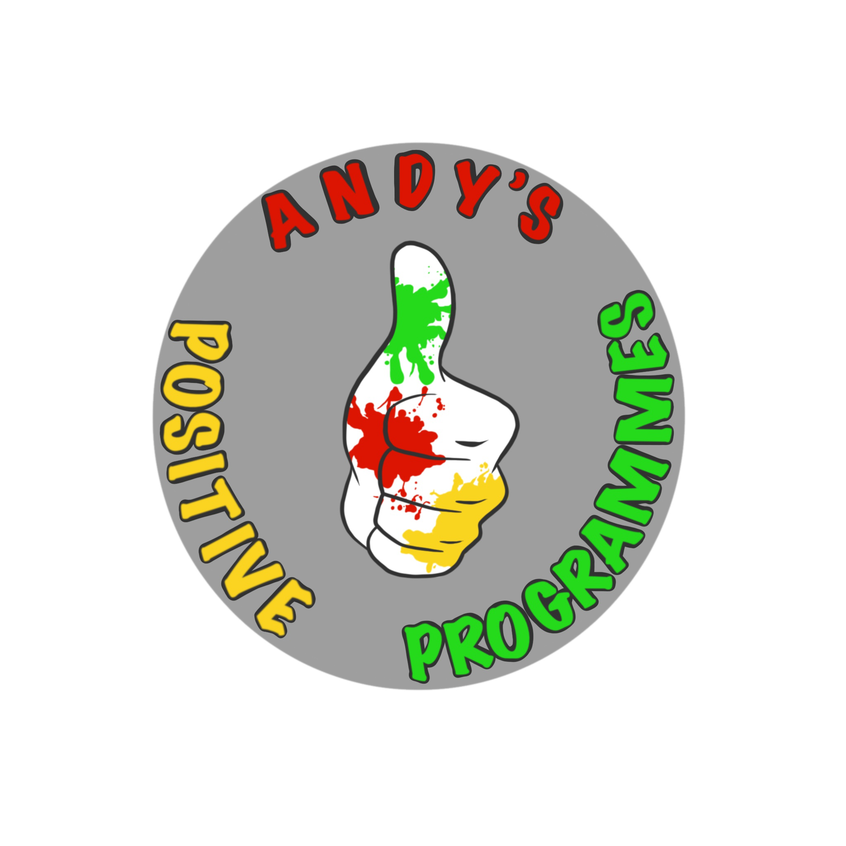

Andrew Robinson
Director
Andy’s Positive Programmes (APP) CIC C/o 12 Warkworth Close
Huyton Knowsley L36 0YL

