19 August 2020

Dear Parent/Carer

As you know, preparations are well under way to welcome all pupils back to Knowsley’s schools in September 2020.

This is a really important step forward as we all look to continue to recover from the impact of the COVID-19 pandemic. Most importantly, for our children and young people, it is a chance to see their friends again. I am sure that you want your child or children to be able to socialise and play safely and also importantly to resume their learning.

We know that returning to school will bring lots of benefits to families, but we also understand that many parents and carers will still be worried about the health and wellbeing of their children when they do start the new term. We also appreciate that many children and young people might themselves have questions about what it will be like when they do go back to school and some may be anxious about what changes might have taken place since they were last in school.

Recognising these concerns, I wanted to take the opportunity to provide some information which I hope provides reassurance that our schools are well prepared and will be safe spaces for your children. In this respect, it is important to note that:-

- All schools in Knowsley have in fact been open throughout the pandemic and providing support for vulnerable children and children of key workers, so plans and procedures have been thoroughly tested and in place for some time;

- In order to make adequate changes to ensure safety, every school in Knowsley has been provided with support from the Council (including from our Public Health professionals);

- All schools in Knowsley have undergone deep cleaning during the summer holidays - regular and thorough cleaning will continue;

- Schools may have made changes to things like drop-off or collection times/locations so that social distancing can be maintained;

- Changes may have been made to classroom layouts and movement through the school buildings in order to promote safe distancing;

- Wherever possible, PE lessons will take place outdoors; and,

- All teachers have been fully briefed and will be working hard to provide reassurance and guidance to children and young people when they do return.

Your child’s school will be in direct contact to make you aware of the details of any specific arrangements but, in the meantime, we have produced a quick guide on what to expect and what to “Remember for September”.

Please be assured that, although the virus is still with us, current cases in Knowsley are low and have been for some time. We continue to monitor and respond to each day’s data and we will continue to work alongside our schools to ensure the safety and wellbeing of all Knowsley pupils – both now and in the future.

I hope that you all enjoy the remainder of the summer and look forward to a happy and healthy new term back at school for our young people.

Yours faithfully
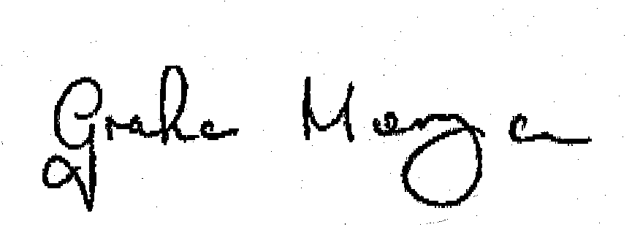

COUNCILLOR GRAHAM MORGAN
Leader of Knowsley Council

